
Expression of Interest – Registration
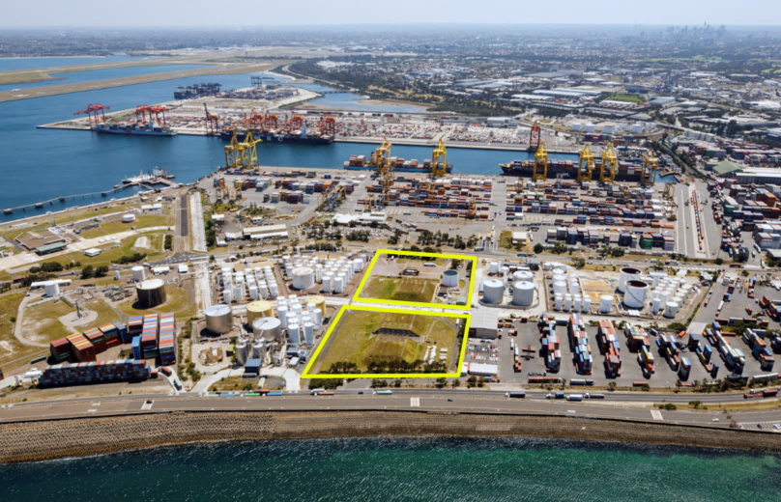

47 Friendship Road and 9 Simblist Road, Port Botany NSW 2036

General information
The Registration form is to be completed and sent via email to: EOI@nswports.com.au.
Completed registration forms and Confidentiality Deeds signed by the Proponent should be lodged no later than 4:00pm Monday, 28 September 2020.
Upon completion of the Registration and following review by NSW Ports, the Proponent will receive:
- a copy of the standard form Lease and Licence Terms to review and accept applicable to the intended use of the Premises;
- a Confidentiality Deed signed by NSW Ports; and
- a copy of the returnable Schedules to complete which will comprise your EOI Submission.
Your EOI Submissions is due by no later than 4.00pm Monday, 26 October 2020.
Please note that incomplete or non-compliant registration forms and Confidentiality Deeds will not be considered further.

Items | PLEASE COMPLETE TABLE BY PROVIDING DETAILS AGAINST EACH ITEM
Entity Name(s) of the Proponent(s)
Trading Name(s) (if applicable)
Parent Company(s) (if applicable)
Company Registration Details (incl. ABN / ACN)
Registered Office(s)
Applicant Name
(Authorised Representative of the Proponent(s))
Position Title(s)
Contact Details
Proposed use of the Premises

Proposed Use of the Premises must align with NSW Ports’ Objectives
NSW POrts Objectives | PLEASE COMPLETE TABLE BY PROVIDING DETAILS AGAINST EACH ITEM  (in your answer please describe how your prosposed use of the premises meets each of the objectives)
Efficient use of road, rail and intermodal facilities
Efficient use of site land and infrastructure
Grow port capacity
Grow rail transport of container
Sustainable operations
Sustainable products

NSW Ports - Confidentiality Deed
“Parties”  “PBO” | Port Botany Operations Pty Limited (ACN 161 204 342) as trustee for the Port Botany Unit Trust (ABN 25 855 834 182)  Address: Brotherson House, Level 2, Gate B103 Penrhyn Road, Port  Botany NSW 2036  Contact: Geraldine Bourgarel (Head of Property)  Phone: +61 419 135 424  Email: EOI@nswports.com.au
“[insert short form name]” | [insert party name] (ABN [insert party’s ABN])  Address: [insert details]  Contact: [insert details]  Phone: [insert details]  Email: [insert details]
“Confidential Information” covered by this Confidentiality Deed | All commercially sensitive information disclosed or made available by one party (the “Discloser”) to the other party (the “Recipient”) under this Deed in connection with the Purpose, together with any information directly or indirectly derived from that information.
“Purpose” for which the Confidential Information is provided | Information provided for the purpose of the EOI for 47 Friendship Road and 9 Simblist Road, Port Botany NSW 2036.
Date of Deed | [insert date]

Executed as a Deed for and on behalf of PBO by its in the presence of:
duly authorised representative, who warrants that he
or she is authorised to sign this Deed:

............................................................... ................................................................
Signature of Authorised Representative Signature of Witness

............................................................... ................................................................
Name (Print) Name (Print)

Executed as a Deed for and on behalf of [insert] by its in the presence of:
duly authorised representative, who warrants that he or
she is authorised to sign this Deed:

............................................................... ................................................................
Signature of Authorised Representative Signature of Witness

............................................................... ................................................................
Name (Print) Name (Print)

General Terms

1 Interpretation

1.1 In this Deed:

“related corporation” means a “Related Body Corporate” as that term is defined in the Corporations Act 2001 (Cth);

“Discloser” means the person disclosing the Confidential Information; and

“Recipient” means the person receiving the Confidential Information.

2 Disclosure of Confidential Information

2.1 The Discloser has absolute discretion as to the Confidential Information that it chooses to disclose.

2.2 The Confidential Information always remains the property of Discloser. This Deed does not give the Recipient any right, title or interest in it.

3 How the parties must treat the Confidential Information

3.1 The Recipient must use the Confidential Information solely for the Purpose. The Recipient must not use or exploit the Confidential Information for its own benefit or for any other purpose including, without limitation, oral or written public statements, announcements and / or press releases, or allow any other person to do so without the Discloser’s written consent.

3.2 Except as provided in clause 3.3, the Recipient must not disclose the Confidential Information to any person, including its contractors, agents or advisers, without the Discloser’s prior written consent.

3.3 The Recipient may disclose the Confidential Information to its related corporations for the Purpose, provided that:

(a) the related corporation is aware of the confidential nature of the Confidential Information; and

(b) the Recipient guarantees that the related corporation will keep the Confidential Information strictly confidential.

3.4 The Recipient must take reasonable steps to protect the Confidential Information and to keep it secure from unauthorised access.

3.5 The Recipient must inform the Discloser immediately if:

(a) it becomes aware or suspects that there has been a breach of the obligations in this Deed or an unauthorised disclosure of Confidential Information by a related corporation of the Recipient; or

(b) it is required to disclose the Confidential Information by law.

3.6 If at any time the Discloser asks for it, the Recipient must return or destroy, and procure that any of its related corporations return or destroy, all Confidential Information covered by this Deed as the Discloser directs, and the Recipient must also destroy all internally generated documents containing the Confidential Information and must provide confirmation to the Discloser of the destruction of such documentation.

3.7 The Recipient does not have to treat as confidential any Confidential Information that:

(a) is or becomes part of the public domain, except information that is or becomes so because it has been disclosed by the Recipient without authority; or

(b) is lawfully known to the Recipient before the date of this Deed; or

(c) is or becomes available to the Recipient from another person who is in possession of it lawfully and can disclose it to the Recipient on a non-confidential basis; or

(d) the Recipient is required by law to disclose, provided that the Recipient must seek to limit that disclosure in any way that the Discloser reasonably requests.

4 Indemnity

4.1 The Recipient indemnifies the Discloser against loss, damage, expenses and costs directly or indirectly arising:

(a) because the Recipient does not observe the material terms or conditions of this Deed for any reason;

(b) from any unauthorised disclosure of Confidential Information by the Recipient’s related corporations; and

(c) in respect of any liability of the Discloser to the Recipient or the Recipient’s related corporations in relation to Confidential Information.

4.2 The Recipient acknowledges that:

(a) a breach of this Deed may cause the Discloser irreparable damage for which damages would likely be an inadequate remedy; and

(b) in addition to any other remedies that may be available, the Discloser may seek injunctive (or similar) relief against any breach or threatened breach of this Deed by the Recipient.

5 Disclaimer

5.1 The Recipient must make its own assessment of all information disclosed by the Discloser.

5.2 The Discloser and its related corporations, and the directors, officers and employees of any of them, are not responsible for and will not be liable in any way to the Recipient or its related corporations in relation to the use of or reliance on the Confidential Information by the Recipient or its related corporations.

6 Privacy

6.1 If any Personal Information is disclosed by the Discloser to the Recipient, the Recipient must:

(a) not use or disclose it except for the Purpose; and

(b) notify the Discloser if the Recipient receives any request for access to that information.

6.2 The Recipient must comply with any reasonable directions which the Discloser gives relating to the Discloser’s obligations under applicable Privacy Laws.

7 General

7.1 This Deed contains the entire agreement between the parties concerning the Purpose and takes the place of all other statements about the Confidential Information. The obligations with respect to Confidential Information imposed by this Deed on the Recipient shall remain in full force and effect for three (3) years from the date of this Deed. Breaches of this Deed prior to expiry shall not affect the rights or remedies of the Discloser.

7.2 This Deed may be varied only if all the parties agree in writing.

7.3 If a party does not exercise a right at any time in connection with a default under this Deed, this does not mean that party has waived the right or cannot exercise it later.

7.4 This Deed is governed by the laws of New South Wales and the parties submit to the non-exclusive jurisdiction of the New South Wales Courts.

8 Capacity

8.1 PBO as trustee for the Port Botany Unit Trust (in this clause 8, the Trustee) receives the benefit of this Deed only in its capacity as trustee for the Port Botany Unit Trust (in this clause 8, the Trust).

8.2 A liability arising under or in connection with this Deed is limited to and can be enforced against the Trustee only to the extent to which it can be satisfied out of the property of the Trust out of which the Trustee is actually indemnified for the liability.

8.3 No person will be entitled to:

(a) claim from or commence proceedings against the Trustee in respect of any liability under this Deed in any capacity other than as trustee for the Trust;

(b) seek the appointment of a receiver, receiver and manager, liquidator, an administrator or any similar office-holder to any property of the Trustee, or prove in any liquidation, administration or arrangement of or affecting the Trustee, except in relation to the property of the Trust; or

(c) enforce or seek to enforce any judgment in respect of a liability under this Deed against the Trustee in any capacity other than as trustee of that Trust.

8.4 The limitation of liability in this clause 8 will not apply to any obligation or liability of the Trustee to the extent that it is not satisfied because under the Deed governing the Trust or by operation of law there is a reduction in the extent of the indemnification of the Trustee out of the assets of the Trust as a result of fraud, negligence or breach of trust of the Trustee or the Trustee waiving or agreeing to amend the rights of indemnification it would otherwise have out of the assets of the Trust.

