ILC at Enfield – Road Transport Coordination Group (RTCG) No39
Date: | Wednesday, 21 September 2022
Time: | 09:00 – 09:45am
Location: | Online - Webex
Invitees: | Chair – Steve Cowley (NSW Ports)  Jonathon Lafforgue (NSW Ports)  Mark Goodall (NSW Ports)  Jarrad Cayzer - NSW Ports  Wayne Ashton (NSW Ports)  Bryan Beudeker (NSW Ports)  Hamish Wood (NSW Ports)  Peter Ushemasimba (NSW Ports)  Claudia Martinovic (BSMS Security)  John Inglese (Strathfield Council)  Geoff DeSantis (Swift Transport)  Frank Andriano (LINX)  Milton Macfarlane (Northside Foods)  Michael Dicembre - Northside Fine Foods  Eugene Quigley – Spandex
Apologies: | Michael Vokonakis - Swift Transport, Tommy Kwak – GOMAPS, Rory Gage - DCE Global, Jason Hwang - Shin Mi, Eugene Quigley – Spandex, Dominic Crinnion – DPE, Paul McFadden – Mapei, Kathy Hackenberg – Harris Farm, Shaun Carpenter – Marinucci, David Lovegrove – Progress Rail
- Action Items from Previous Minutes
item | action | Status | comments
1 | NSW Ports to continue to engage with Traffic Engineers in response to concerns about road width for B-Double & Super B-Doubles to turn safely on the corner of Norfolk and Wentworth St. | Completed | Tenants to work directly with Strathfield Council Traffic Engineer (John Inglese)
2 | Gate T8 must remain accessible as an emergency exit, LINX to inspect during site inspection | Completed | Inspected during last site inspection
3 | NSW Ports to provide contact details of Strathfield Council traffic engineer | Completed | John Inglese (Traffic Engineer) to attend future RTCG meetings

- Infrastructure Update
  - Precinct A, Precinct E and Precinct H update
(MG) No updates at either location. Precinct A and precinct E remain undeveloped.
- Operations Update
  - LINX Intermodal Terminal (FA)
Similar to the previous meeting we have seen an increased in export volumes, additional rail windows are supporting the increased volume. Besides that, business is operating as per usual with no issues to raise.
  - Swift Transport (GDS)
Additional yard space has been acquired at a facility (Bus Depot) of Cosgrove Road to help manage increased truck and container volumes.
We have recently changed our traffic flow within the facility, traffic will now enter via gate D1 and exit via gate D2 (refer to appendix 1)
  - Spandex
Operational the facility remains busy with increased throughput. Also, a point worth raising, I have seen an increased number of vehicles stopping on Mainline Dr and or queuing for the swift facility, when this occurs it can be difficult to safely access our precinct.
(GDS) If queuing occurs outside the Swift facility, please instruct the depot manager (Spandex) to call me immediately and we will initiate traffic management controls.
  - Northside Fine Foods (MD)
Shortage of staff parking has been resolved, nothing major to report.
  - GOMAPS
No representative in attendance.
  - DCE Global
No representative in attendance.
  - Shin Mi
No representative in attendance.
  - Mapei
No representative in attendance.
  - Harris Farm (Oli)
  - Marinucci
No Representative in attendance.
  - Operational Interfaces
No Representative in attendance.
  - Strathfield Council (JI)
The reclassification of Norfolk and Wentworth Street remains under application.
Additional speed signage (50kph) has been positioned on Wentworth Street.
- New business
  - (MG) Updated Road Signage
We have recently replaced faded signage around the Enfield precinct, in addition we have also taken the opportunity to include additional speed signage along Mainline Dr.
  - (SC) Cosgrove Road and Turnout Drive Modifications
As I discussed at the August Enfield Tenant Safety Meeting, NSW Ports has now confirmation of dates for the Cosgrove Road and Turnout Drive intersection upgrade. We have now received the approved ROL from TfNSW and also have the attached Traffic Control Plan covering the work. The timing for the work is scheduled as nightworks on 26, 27, 28 and 29 of September between the hours of 2030 and 0500 across these four nights. I have advised the Traffic Manager at Strathfield Council of these dates and provided copy of the TCP and ROL for their information (Refer to Appendix 2)
  - DPIE Traffic Reports
A reminder to all tenants that capturing of TEU volumes by road and rail is mandatory requirement. For the upcoming Independent Environment Audit NSWP we have now received the data, this will be collated and form of the audit reporting requirements.
Into the future, should tenants need any assistance with populating the data, please feel free to reach out to me directly.

  - (SC) Update on traffic observations within the precinct
These are observations that have been identified by the precinct Security provider (BSMS) in total for the period June to September, we recorded a total of 171 traffic observations.
- 22 Speeding observations – (CM) most likely staff members entering and exiting the precinct
- 121 were illegal manoeuvres
- 28 unauthorised parking/stopping events.
Majority of illegal manoeuvres reported were the result of oversized vehicles (Greater than 6m) turning left from Cosgrove Rd into turnout Dr, this will be addressed with the road modifications at this intersection (Refer to 4.2)

  - (PU) Debrief Annual Emergency Exercise
The annual Enfield emergency exercise simulated a LINX forklift operator recognising a Dangerous Goods container with a compromised bottom valve which is leaking the class 6.1 product Toluene Diisocyanate. The exercise was attended by representatives from NSW Ports Operations team, LINX Terminal Management, BSMS Security, SWIFT and Fire & Rescue Zone Commander Peter Jacobs. The exercise was conducted in three phases:
- Identification of Leak.
- Arrival of Emergency Services.
- Intermodal Terminal (IMT) Evacuation.
At the conclusion of the panel discussion action items for both LINX and NSW Ports were recognised. Firstly, LINX were unable to identify a secondary emergency control point to be utilised if their primary location of the Gatehouse was compromised in an exclusion zone. Therefore, it was agreed for LINX to include the NSWP Admin Building in their ERP due to its proximity to LINX and its ease of access through Service Rd.
- Next meeting
Thursday 15th December 2022

Appendix 1 – Swift: Revised Traffic Management Plan (TMP)

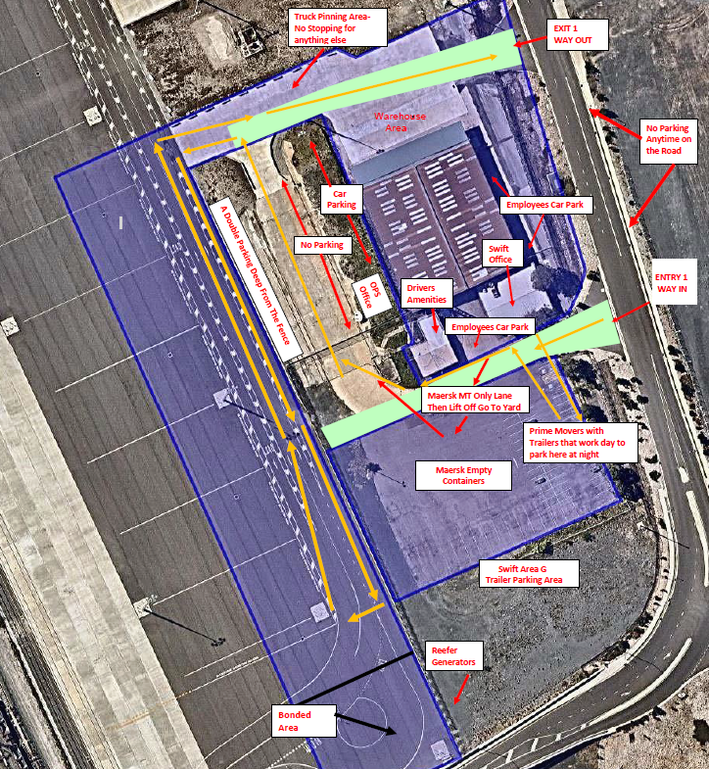

Appendix 2: Cosgrove Road and Turnout Drive Modifications

